

SC2006 - Software Engineering
Lab 4 Deliverables

Lab Group | SCED
Team | Glitch
Members | Harshil Gupta (U2421166J)
Members | Goh Jin Long Abdillah (U2321634L)
Members | Guan Yibin (U2423353E)
Members | Kumar Preetham (U2422986F)
Members | Goh Jun Xian Bryant (U2423462J)

1. Black Box Testing 3
I. AuthController 3
II. SearchController 3
III. Equivalence Class and Boundary Value Testing 4
IV. Test Cases and Results 6
a) Login 6
b) Signup 7
c) Destination Search (Set Destination) 8
d) Display Nearby Carparks (List/Map) 9
e) EV Charger Discovery & Live Availability 10
f) EV Filters: Connector Type & Charging Speed 11
2. White Box Testing 12
I. Login 12
a. Control Flow Graph 12
b. Basic Path Testing 13
c. Test Cases and Results 13
II. Destination Search & Nearby Carparks 14
a. Control Flow Graph 14
b. Basic Path Testing 15
c. Test Cases and Results 15
III. EV Live Charger Availability 16
a. Control Flow Graph 16
b. Basic Path Testing 17
c. Test Cases and Results 17

Black Box Testing

I. AuthController
The AuthController class manages end-user authentication for ParkMate, specifically account creation (sign-up), login, password reset, and permanent account deletion. For login, the controller accepts an email and password, validates the input, and verifies the submitted password against the stored salted hash of the corresponding user record. If the credentials are valid and the account is not restricted, the controller issues a secure session or token and returns the user to the application’s home context; on failure it returns a generic authentication error without revealing which field was incorrect. Observable behaviours include clear messages when an email is not registered, and graceful handling when the authentication service or backend is unreachable. Security-relevant aspects are part of the externally visible contract: secure session management is required, sensitive fields are never echoed in responses, and service-level errors are surfaced with user-safe wording.
For account creation, the controller validates essential profile fields and enforces email uniqueness before persisting the new user record with a hashed password. On success it creates a new user identifier and the account becomes available for subsequent login. The controller also supports user-initiated password resets by sending a reset link via email and enforcing token expiry; after a valid reset flow the user can set a new password and continue using the system. Finally, users may permanently delete their account; upon confirmation the controller removes the account and associated preferences, with the operation marked as irreversible. These behaviours are specified in ParkMate’s use cases and constitute the observable interface that our black-box tests will exercise end-to-end.

II. SearchController
The SearchController class manages the discovery flow for carparks and EV charging locations in ParkMate. It accepts either a destination text query (with geocoding suggestions) or a location context (“Current Location”), validates inputs, and sets the selected place as the search destination. Once a destination is set, the controller retrieves and returns a list or map of nearby carparks around that destination. The response includes key details for each carpark such as name, distance, live lot availability, price, height limit, and the last-updated time; user interactions like selecting a marker or list item save the chosen carpark to history. When input is invalid (for example, gibberish addresses) the controller returns a clear validation message; when external services are unavailable (geocoding, carpark database) it surfaces a user-safe error and preserves app continuity where possible. These behaviours define the externally observable contract that will be verified via black-box tests.
For EV charging, the controller—working with the EV data services—fetches nearby stations and returns charger-level information including availability state, connector type, charging speed, and last-updated time. Results refresh automatically every one to two minutes or on manual refresh, with data-freshness communicated explicitly in the payload so the client can show a visible “last updated” indicator. If live feeds are temporarily unavailable, the controller returns the last known results with a clear stale-data notice. The EV experience is integrated with ParkMate’s filter and sort capabilities so users can narrow by connector type and charging speed while still benefiting from deterministic, reproducible ordering in the returned list or map. These behaviours provide a stable specification for black-box validation without reliance on internal implementation details.

III. Equivalence Class and Boundary Value Testing
Equivalence Class Testing
A basic black-box test design technique in which test cases are designed to execute representatives from equivalence partitions. Equivalence classes (partitions) are portions of an input or output domain. The behavior of a component is assumed to be the same for every member of a partition class; therefore we choose at least one value from each valid class and at least one value from each invalid class to achieve good coverage with few tests. In ParkMate, we identify valid classes that the system should accept and process normally and invalid classes that the system should reject with clear messages. We apply the lecture rule of one valid EC and two invalid ECs for ranges, and one valid / one invalid EC for discrete sets, ensuring each test contains at most one invalid input so error handling can be isolated.
Boundary Value Testing
Boundary Value Testing extends equivalence partitioning when members of an input class are ordered. It focuses on edges or limits where faults are most likely to appear. For ParkMate, natural boundaries arise at empty vs non-empty text, token/expiry cut-offs, and data-freshness thresholds (e.g., EV updates every 1–2 minutes), so we design tests on, just below, and just above those limits.

- Login Function (AuthController)
Valid Equivalence Class: Syntactically valid email paired with a password; user exists; credentials match; backend reachable → user is authenticated and navigated to Home
Invalid Equivalence Class: Malformed or unregistered email; wrong password; locked or non-existent account; backend unavailable → generic authentication error or “Unable to connect” without leaking which field failed
Boundary Values: Empty vs one-character password (empty treated as invalid input), and exactly one failed attempt before lockout policies are considered (functional behavior remains generic error as specified)

- Sign-Up Function (Auth Controller)
Valid Equivalence Class: Name/email present in correct format; password meets policy (ideally ≥12 characters with a mix of upper/lowercase, numbers and symbols); confirm password matches; email not already registered → account created and ready for subsequent login
Invalid Equivalence Class: Malformed email; weak password that does not meet stated requirements; confirm password mismatch; duplicate email; transient network/server error → specific error messages such as “Email already in use,” “Password must meet the requirements,” or “Service unavailable.”
Boundary Values: Password strength right at the policy edge (e.g., exactly meeting vs just missing the composition guideline), and confirm-password exactly equal vs off by one character

- Destination Search & Selection (SearchController)
Valid Equivalence Class: Non-empty, human-readable destination text or “Current Location”; geocoding API reachable; user selects one of the suggestions → destination is set and nearby carparks are shown
Invalid Equivalence Class: Gibberish/special-character input the geocoder cannot resolve; geocoding API unavailable; carpark database unreachable → “No matching locations found,” “Unable to retrieve location data. Please try again later,” or equivalent error
Boundary Values: Query length at the edge of acceptance (empty string representing “Current Location” vs one-character query), and suggestion list size at boundaries (no suggestions vs exactly one suggestion) with correct messaging and flow back to input

- Display Nearby Carparks (SearchController)
Valid Equivalence Class: Destination selected; carpark data available → ParkMate displays nearby carparks in map or list view with name, distance, live availability, price, height limit and last-updated time; selecting an item writes to history
Invalid Equivalence Class: Carpark data service unavailable; map rendering failure → user sees “Carpark information unavailable. Please try again later” or system falls back to list view
Boundary Values: Exactly zero results vs one result displayed; last-updated timestamp at the freshness threshold still shows a valid “Last updated HH:MM” rather than an error

- EV Charger Discovery & Live Availability (SearchController / EV features)
Valid Equivalence Class: Location or destination known; EV data source reachable; chargers exist in area → stations appear with availability states (available/in use/offline), connector type and charging speed, and a visible last-updated time; results auto-refresh or update on manual refresh
Invalid Equivalence Class: No chargers found; device location permission denied and no destination set; external data source offline → friendly “No EV chargers found…” guidance, prompt to enter destination, or cached results with “Live data temporarily unavailable.”
Boundary Values: Data-freshness exactly at the 1–2 minute update window (just before and just after the threshold); manual refresh immediately after auto-refresh; zero available connectors transitioning to one available connector displays the correct state and ordering

- EV Filters: Connector Type & Charging Speed
Valid Equivalence Class: Connector types drawn from the supported set (e.g., Type 2, CCS2, CHAdeMO) and a recognised charging-speed category; applying filters narrows results without excluding valid matches
Invalid Equivalence Class: Unsupported connector label; contradictory filters that yield no possible results → empty state with clear guidance to adjust filters
Boundary Values: Toggling a single connector type vs the full set; clearing all filters vs applying exactly one filter; last-updated carried through filtered lists at the freshness edge

IV. Test Cases and Results

Login
Input parameters: Email and Password
No. | Test Input | Expected Output | Actual Output | Pass?
1. | (Valid) Email: user1@parkmate.app  (Valid) Password: valid hash match | Successful login; session/token issued; navigate to Home | Successful login; session/token issued; navigate to Home
2. | (Invalid) Email: “”  (Valid) Password: ValidPass!1234 | Login failed; system notifies “Please enter your email and password.” | Login failed; system notifies “Please enter your email and password.”
3. | (Invalid) Email: test123  (Valid) Password: ValidPass!1234 | Login failed; system notifies “Please enter a valid email.” | Login failed; system notifies “Please enter a valid email.”
4. | (Valid) Email: user1@parkmate.app  (Invalid) Password: “” | Login failed; system notifies “Please enter your email and password.” | Login failed; system notifies “Please enter your email and password.”
5. | (Valid) Email: user1@parkmate.app  (Invalid) Password: wrong secret | Login failed, system notifies “Invalid email or password.” (generic, no field leakage) | Login failed, system notifies “Invalid email or password.” (generic, no field leakage)
6. | (Invalid) Email: ghost@parkmate.app (not registered)  (Valid) Password: any | Login failed, system notifies “Invalid email or password.” | Login failed, system notifies “Invalid email or password.”
7. | (Valid) Email: user1@parkmate.app  (Valid) Password: valid (Service Down) | Login failed, system notifies “Unable to connect. Please try again later” | Login failed, system notifies “Unable to connect. Please try again later”

Signup
Input parameters: Name, Email, Password, Confirm Password
No. | Test Input | Expected Output | Actual Output | Pass?
1. | (All Valid Inputs)  Name: “Zerius Heng”  Email: zerius0139@gmail.com  Password: ParkMate!2025  Confirm Password: ParkMate!2025 | Successful signup; useID created, account can log in thereafter | Successful signup; useID created, account can log in thereafter | Yes
2. | (All valid except Name) Name: “” | System notifies “Name is required.” | System notifies “Name is required.” | Yes
3. | (All Valid except Email)  Email: “” | System notifies “Please enter a valid email.” | System notifies “Please enter a valid email.” | Yes
4. | (All Valid except Password)  Password: “” | System notifies “Please fill in all required fields.” | System notifies “Please fill in all required fields.” | Yes
5. | (Weak Password) Password: password  Confirm: password | System notifies “Password does not meet the requirements.” | System notifies “Password does not meet the requirements.” | Yes
6. | (Mismatch Password) Password: ParkMate!2025  Confirm: ParkMate!2024 | System notifies “Passwords do not match.” | System notifies “Passwords do not match.” | Yes
7. | (Duplicate Email)  Email already registered | System notifies “Email already in use.” | System notifies “Email already in use.” | Yes
8. | (Valid Inputs) with transient DB error | System notifies “Service unavailable. Please try again later.” | System notifies “Service unavailable. Please try again later.” | Yes

Destination Search (Set Destination)
Input parameters: Text query or Current location

No. | Test Input | Expected Output | Actual Output | Pass?
1. | (Valid) Query: “NTU North Spine” | Geocoding suggestions shown; user selects a suggestion; destination set | Geocoding suggestions shown; user selects a suggestion; destination set | Yes
2. | (Valid) Use “Current Location” (permission granted) | Destination set to current coordinates | Destination set to current coordinates | Yes
3. | (Invalid) Query: “#@$$%” | System notifies “No matching locations found.” | System notifies “No matching locations found.” | Yes
4. | (Service Down) Geocoding unavailable | System notifies “Unable to retrieve location data. Please try again later.” | System notifies “Unable to retrieve location data. Please try again later.” | Yes
5. | (Permission Denied) Current Location denied; empty query | System prompts to enter a destination text | System prompts to enter a destination text | Yes

Display Nearby Carparks (List/Map)
Precondition: Destination set successfully

No. | Test Input | Expected Output | Actual Output | Pass?
1. | (Valid) Destination set to “NTU North Spine” | Nearby carparks displayed with name, distance, price, height limit, live availability, last updated. | Nearby carparks displayed with name, distance, price, height limit, live availability, last updated. | Yes
2. | (Zero Results) Area with no carparks | System shows “No nearby carparks found” with the option to adjust the destination | System shows “No nearby carparks found” with the option to adjust the destination | Yes
3. | (Data Stale) Provider returns cached data | Results shown with “Last updated…” freshness indicator; no crash | Results shown with “Last updated…” freshness indicator; no crash | Yes
4. | (Select Item) Tap marker/list item | Carpark details open and saved to history | Carpark details open and saved to history | Yes
5. | (Service Down) Carpark data API unavailable | System notifies “Carpark information unavailable. Please try again later.” | System notifies “Carpark information unavailable. Please try again later.” | Yes

EV Charger Discovery & Live Availability
Input parameters: Destination/location context (as above)

No. | Test Input | Expected Output | Actual Output | Pass?
1. | (Valid) Destination with chargers | Show stations with availability state, connector type, charging speed, and last updated | Show stations with availability state, connector type, charging speed, and last updated | Yes
2. | (Auto Refresh) Wait 1 minute | Data refreshes; last updated time changes accordingly | Data refreshes; last updated time changes accordingly | Yes
3. | (No Chargers) Area without chargers | The system shows “No EV chargers found nearby” guidance | The system shows “No EV chargers found nearby” guidance | Yes
4. | (Feed Down) EV data source offline | Show last known results with a clear notice “Live data temporarily unavailable.” | Show last known results with a clear notice “Live data temporarily unavailable.” | Yes
5. | (Manual Refresh) Pull to refresh immediately after auto refresh | No errors; consistent latest timestamp | No errors; consistent latest timestamp | Yes

EV Filters: Connector Type & Charging Speed
Input parameters: connectorTypes, chargingSpeed, requireAvailable

No. | Test Input | Expected Output | Actual Output | Pass?
1. | (Valid) Connector Types: {Type 2, CCS2} Charging Speed: “Fast” | List/map shows only matching stations; last update retained | List/map shows only matching stations; last update retained | Yes
2. | (Valid) Require Available: true | Results show only stations with at least one available connector | Results show only stations with at least one available connector | Yes
3. | (Contradictory) Filters yield empty set | Empty state with guidance to clear or adjust filters | Empty state with guidance to clear or adjust filters | Yes
4. | (Preference Memory) Apply filter, navigate away, return | Prior EV filter preferences are remembered and applied | Prior EV filter preferences are remembered and applied | Yes

2. White Box Testing

Login

Control Flow Graph
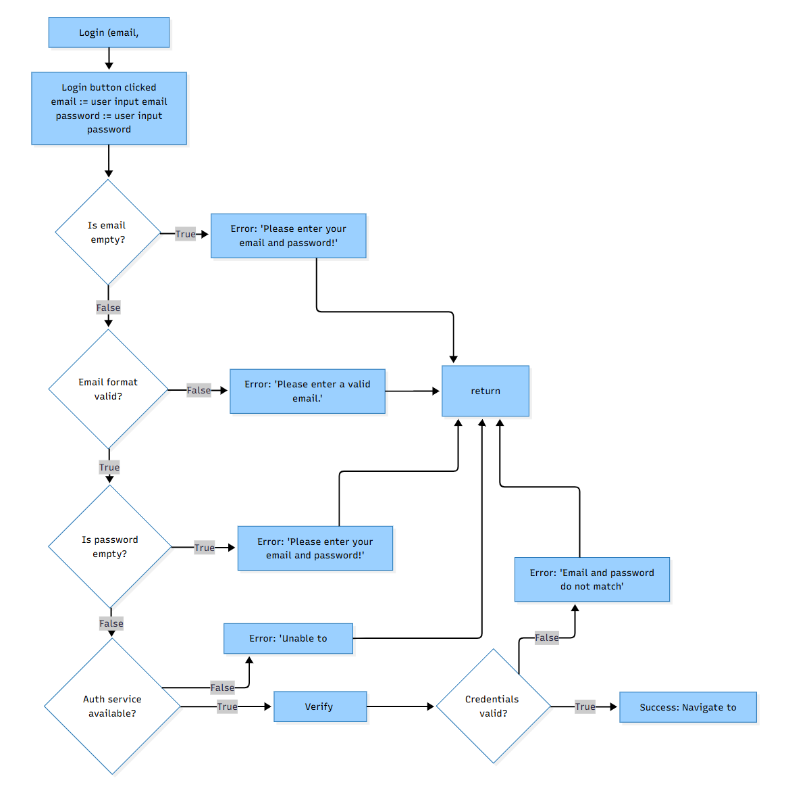

Basic Path Testing

Cyclomatic Complexity = | decision points | + 1 = 5 + 1 = 6

Basis Paths:
- Baseline path: 1 → 2 → 3(F) → 5(T) → 7(F) → 9(T) → 11 → 12(T) → 15
- Basis path 2: 1 → 2 → 3(T) → 4 → 14
- Basis path 3: 1 → 2 → 3(F) → 5(F) → 6 → 14
- Basis path 4: 1 → 2 → 3(F) → 5(T) → 7(T) → 8 → 14
- Basis path 5: 1 → 2 → 3(F) → 5(T) → 7(F) → 9(F) → 10 → 14
- Basis path 6: 1 → 2 → 3(F) → 5(T) → 7(F) → 9(T) → 11 → 12(F) → 13 → 14

c. Test Cases and Results
Login(email, password)
No. | Test Input | Expected Output | Actual Output | Pass?
1. | email = user1@parkmate.app  password = Correct#2025 | Log in successfully → navigate to Home | Log in successfully → navigate to Home | Y
2. | email = “”  password = Correct#2025 | “Please enter your email and password!” | “Please enter your email and password!” | Y
3. | email = admin1  password = Correct#2025 | “Please enter a valid email.” | “Please enter a valid email.” | Y
4. | email = admin1@  password = Correct#2025 | “Please enter a valid email.” | “Please enter a valid email.” | Y
5. | email = user1@parkmate.app  password = “” | “Please enter your email and password!” | “Please enter your email and password!” | Y
6. | email = ghost@parkmate.app  password = Any#1234 | “Email and password do not match” | “Email and password do not match” | Y
7. | email = user1@parkmate.app  password = Correct#2025  Auth service down | “Unable to connect” | “Unable to connect” | Y

II. Destination Search & Nearby Carparks

Control Flow Graph

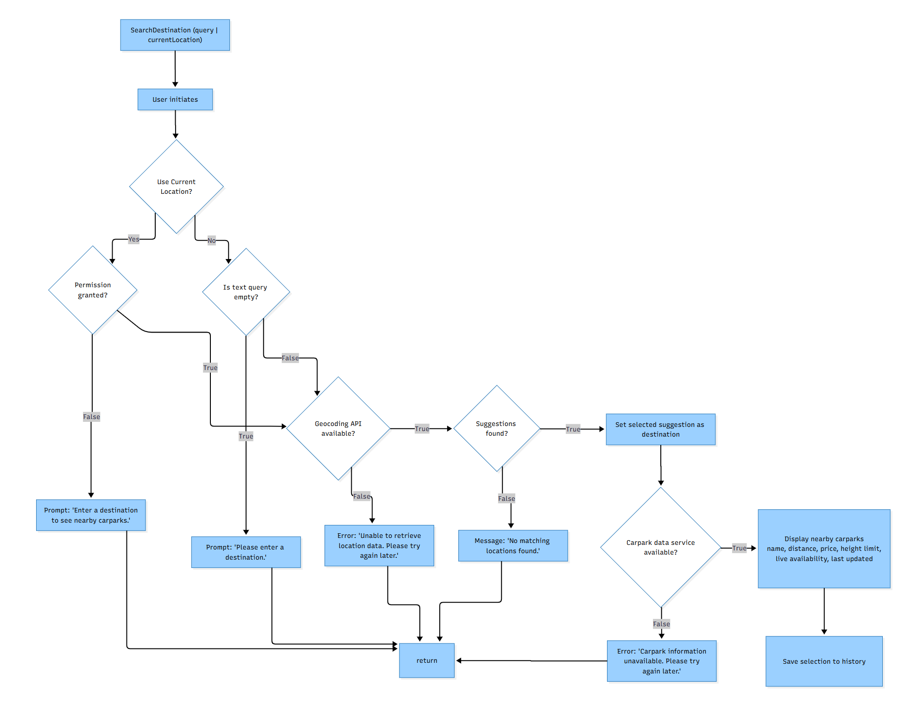

Basic Path Testing

Cyclomatic Complexity = | decision points | + 1 = 6 + 1 = 7
(Decisions at D3, D3a, D4, D5, D6, D8)

Basis Paths:
- Baseline path: 1 → 2 → 3(No) → 4(F) → 5(T) → 6(T) → 7 → 8(T) → 9 → 10
- Basis path 2: 1 → 2 → 3(No) → 4(T) → 4e → 14
- Basis path 3: 1 → 2 → 3(No) → 4(F) → 5(F) → 5e → 14
- Basis path 4: 1 → 2 → 3(No) → 4(F) → 5(T) → 6(F) → 6e → 14
- Basis path 5: 1 → 2 → 3(Yes) → 3a(F) → 3e → 14
- Basis path 6: 1 → 2 → 3(Yes) → 3a(T) → 5(F) → 5e → 14
- Basis path 7: 1 → 2 → 3(Yes) → 3a(T) → 5(T) → 6(T) → 7 → 8(F) → 8e → 14

c. Test Cases and Results
SearchDestination(query | currentLocation)=
No. | Test Input | Expected Output | Actual Output | Pass?
1. | Query mode: “NTU North Spine” | Suggestions shown → user selects → destination set → nearby carparks displayed with name, distance, price, height limit, live availability, last updated; selection saved to history | Suggestions shown → user selects → destination set → nearby carparks displayed with name, distance, price, height limit, live availability, last updated; selection saved to history | Y
2. | Query mode: “” | Prompt “Please enter a destination” | Prompt “Please enter a destination” | Y
3. | Query mode: “@@@###” | “No matching locations found” | “No matching locations found” | Y
4. | Query mode: “NTU North Spine”, Geocoding down | “Unable to retrieve location data. Please try again later.” | “Unable to retrieve location data. Please try again later.” | Y
5. | Current Location mode (permission granted) | Destination set to device location → nearby carparks displayed with full details | Destination set to device location → nearby carparks displayed with full details | Y
6. | Current Location mode (permission denied), no query | Prompt “Enter a destination to see nearby carparks.” | Prompt “Enter a destination to see nearby carparks.” | Y
7. | Destination set, Carpark data service unavailable | “Carpark information unavailable. Please try again later.” | “Carpark information unavailable. Please try again later.” | Y

III. EV Live Charger Availability

Control Flow Graph

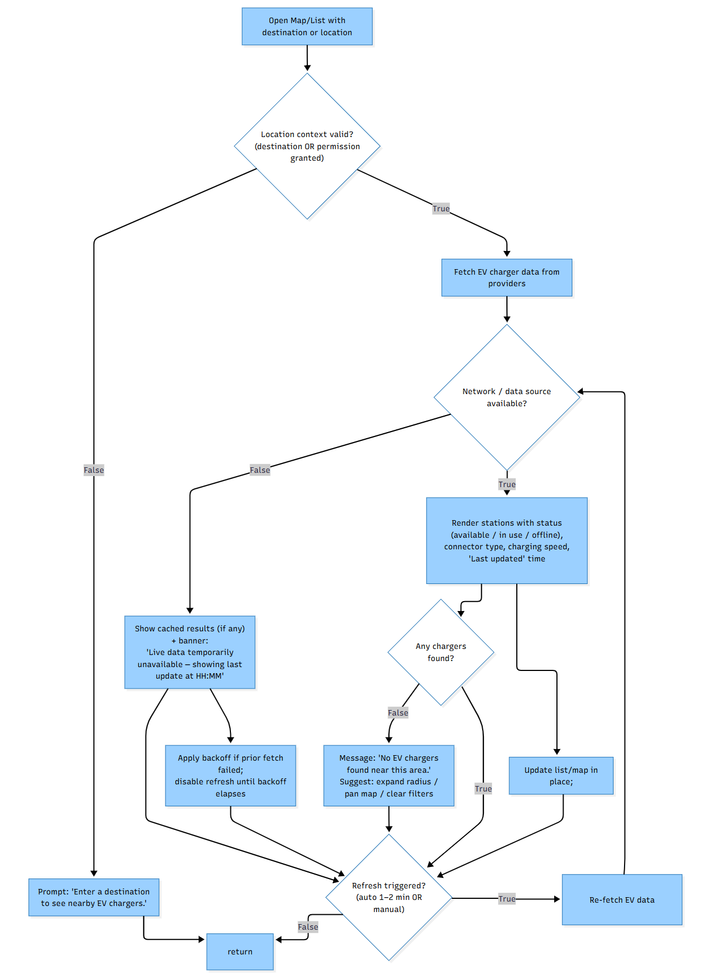

Basic Path Testing
Cyclomatic Complexity = | decision points | + 1 = 5 + 1 = 6
(Decisions at DC3, DC4, DC6, DC7 and the DC4 re-check after refresh)

Basis Paths:
- Baseline path: 1 → 3(T) → 2 → 4(T) → 5 → 6(T) → 8 → 7(F) → 14
- Basis path 2: 1 → 3(F) → 3e → 14
- Basis path 3: 1 → 3(T) → 2 → 4(F) → 4e → 7(F) → 14
- Basis path 4: 1 → 3(T) → 2 → 4(T) → 5 → 6(F) → 6e → 7(F) → 14
- Basis path 5: 1 → 3(T) → 2 → 4(F) → 4e → 7(T) → 7a → 7(F) → 14
- Basis path 6: 1 → 3(T) → 2 → 4(T) → 5 → 6(T) → 8 → 7(T) → 7b → 4(T) → 5 → 8 → 7(F) → 14

c. Test Cases and Results
No. | Test Input | Expected Output | Actual Output | Pass?
1. | Valid Destination; network/data source available; area has chargers | Stations rendered with status (available / in use / offline), connector type, charging speed, and Last updated timestamp | Stations rendered with status (available / in use / offline), connector type, charging speed, and Last updated timestamp | Y
2. | No destination and location permission denied | Prompt “Enter a destination to see nearby EV chargers” | Prompt “Enter a destination to see nearby EV chargers” | Y
3. | Valid destination; data source down | Show cached results (if any) with banner “Live data temporarily unavailable — showing last update at HH:MM.” | Show cached results (if any) with banner “Live data temporarily unavailable — showing last update at HH:MM.” | Y
4. | Valid Destination; no chargers in area | Message “No EV chargers found near this area.” with guidance to expand radius, pan map, or clear filters | Message “No EV chargers found near this area.” with guidance to expand radius, pan map, or clear filters | Y
5. | Auto refresh occurs ~1-2 minutes after case #1 | Data is re-fetched; Last updated time advances; list/map updates in place without losing scroll or selection | Data is re-fetched; Last updated time advances; list/map updates in place without losing scroll or selection | Y
6. | Manual refresh immediately after a failed fetch (backoff active) | Refresh is temporarily disabled until backoff elapses; cached results remain visible with the stale-data banner | Refresh is temporarily disabled until backoff elapses; cached results remain visible with the stale-data banner | Y
7. | Active EV filters (e.g., Type 2 + DC Fast) applied; refresh triggers (auto or manual) | Results remain filtered after refresh; only matching stations appear; Last updated reflects the new fetch time | Results remain filtered after refresh; only matching stations appear; Last updated reflects the new fetch time | Y

